**C Programming Exercise A**

**Questions:**

1. **Write a program in C to display the first 10 natural numbers.**

**Solution in Dev-C++:**

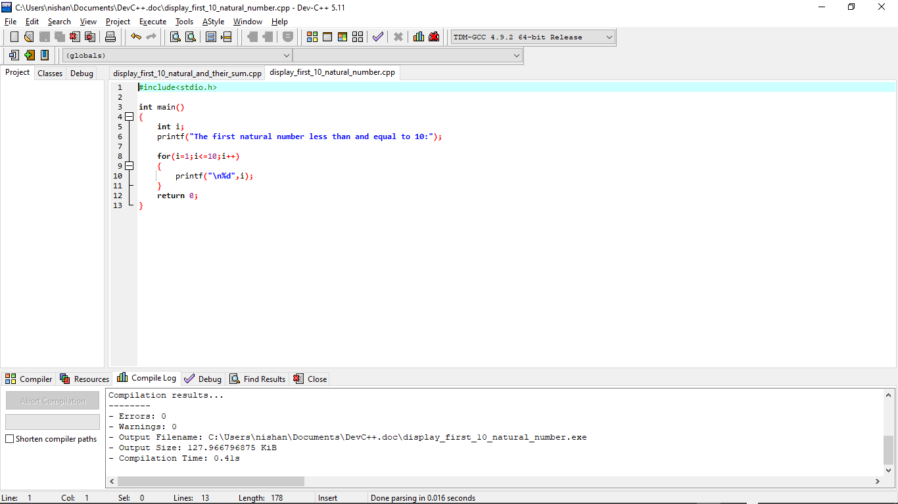

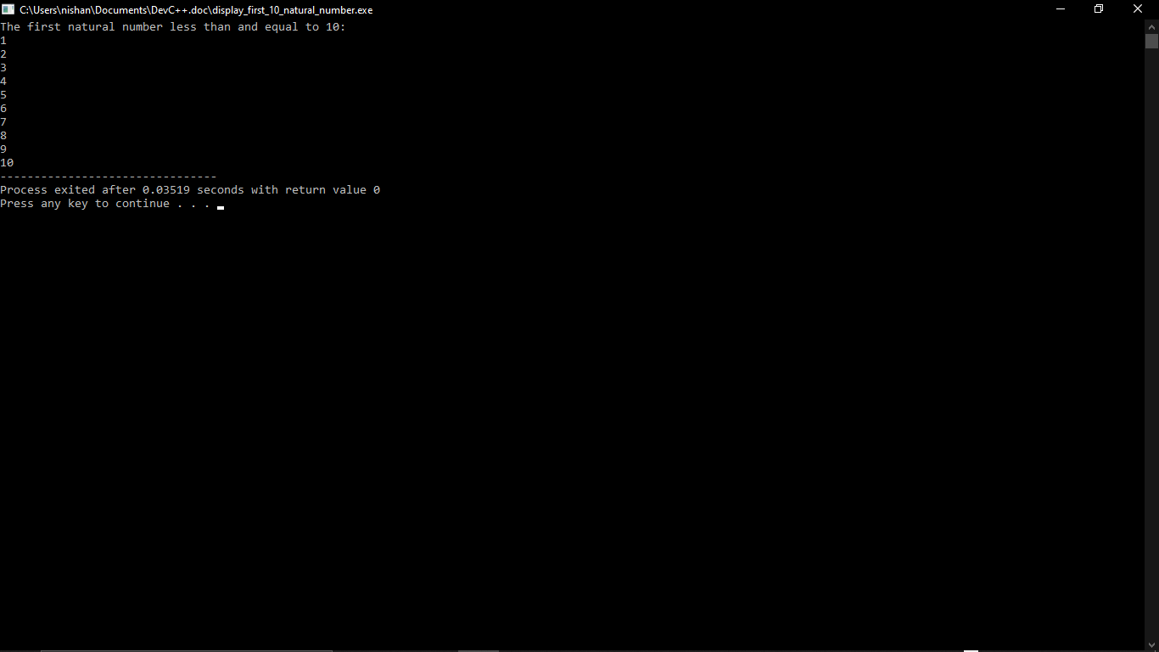**Output:**

1. **Write a C program to find the sum of first 10 natural numbers.**

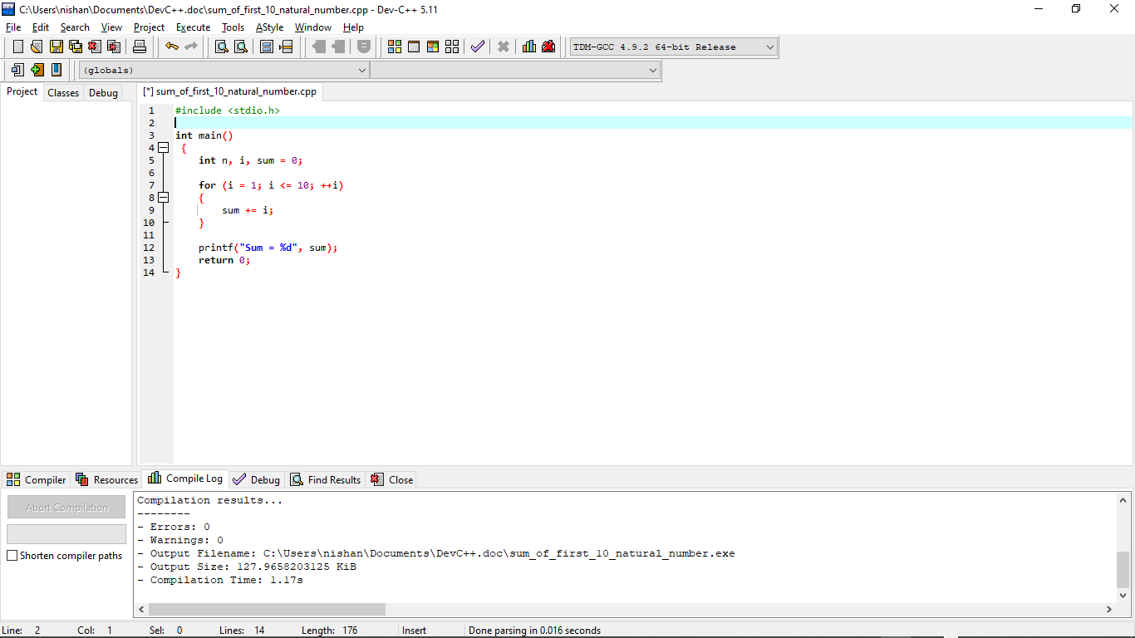**Solution in Dev-C++:**

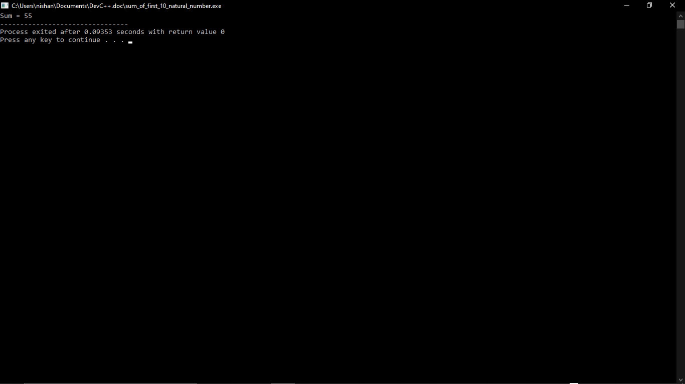**Output:**

1. **Write a program in C to display n terms of natural number and their sum.**

**Solution in Dev-C++:**

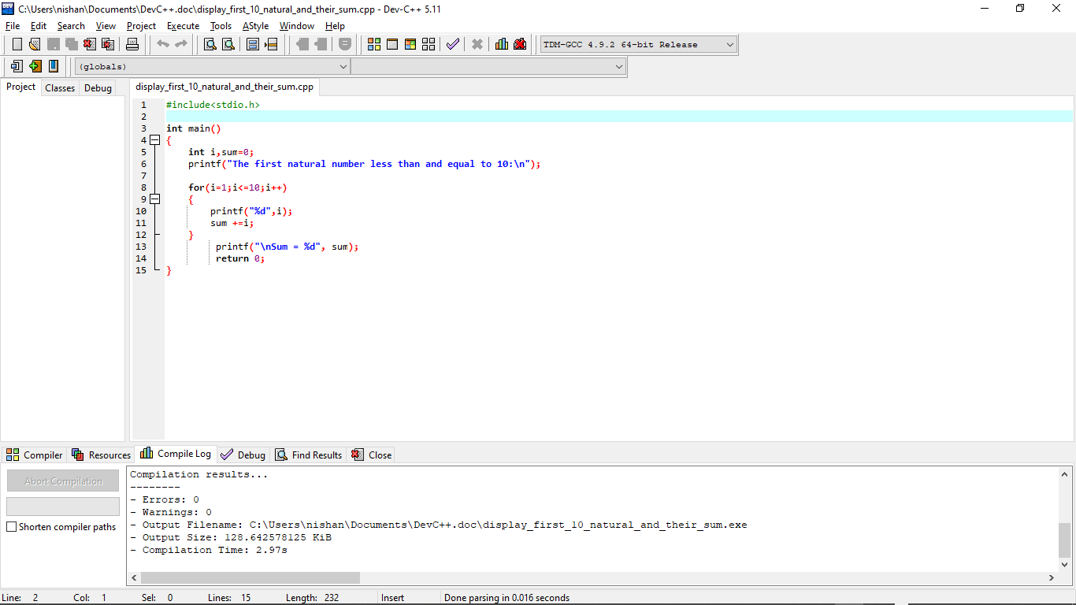

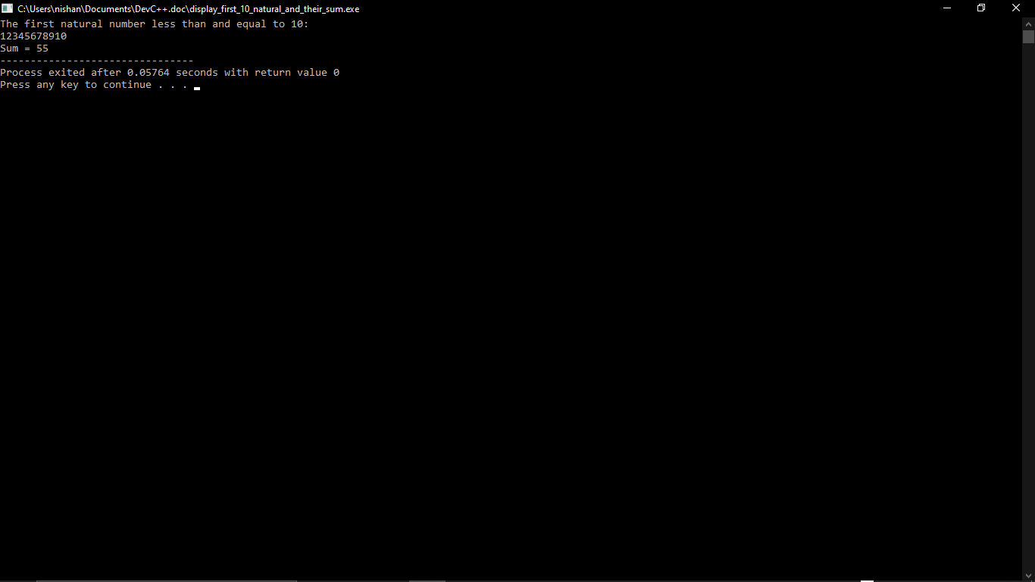**Output:**

1. **Write a program in C to display the multiplication table of a given integer.**

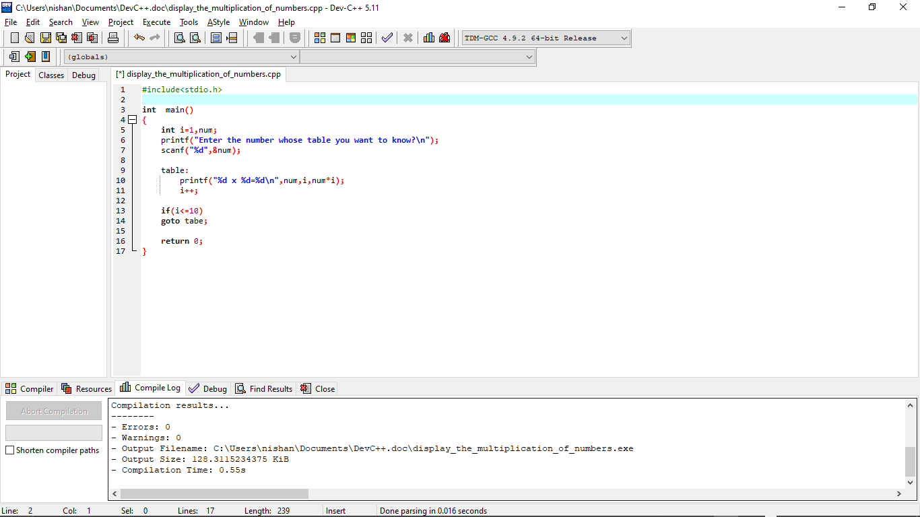**Solution in Dev-C++:**

**Output:**

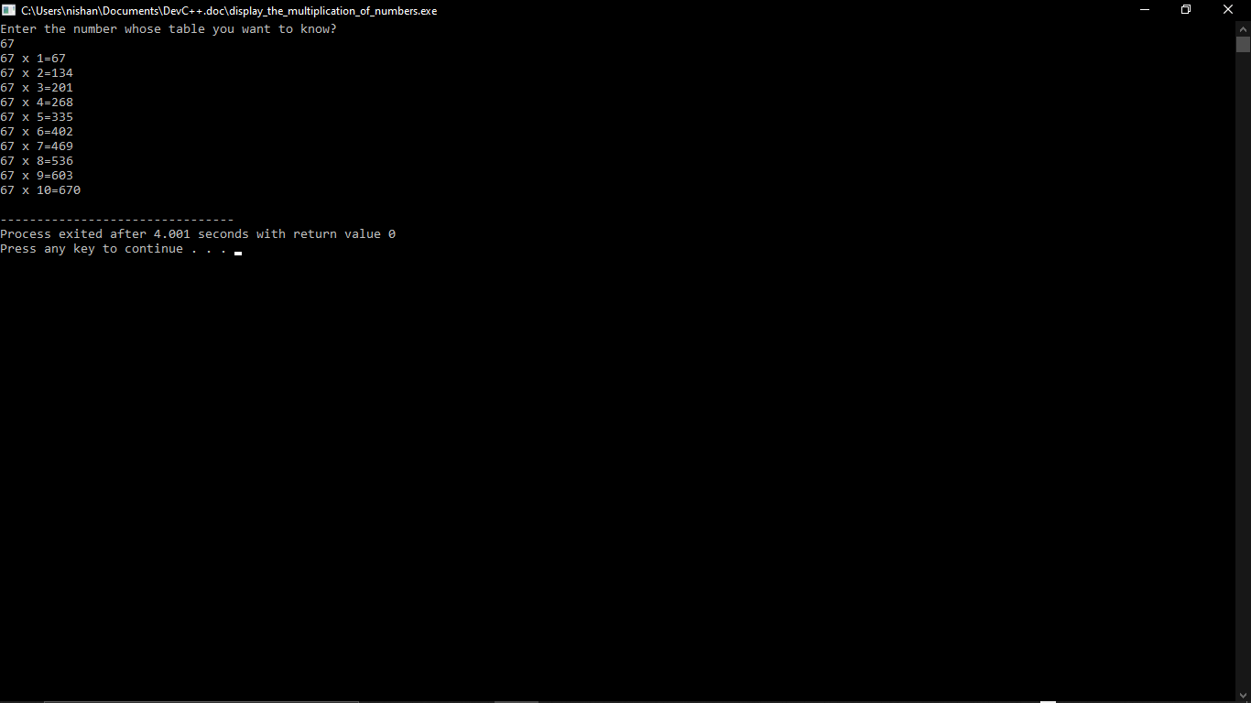

1. **Write a program in C to display the pattern like right angle triangle using an asterisk.**

**The pattern like:**

**\***

**\* \***

**\* * \***

**\* * * \***

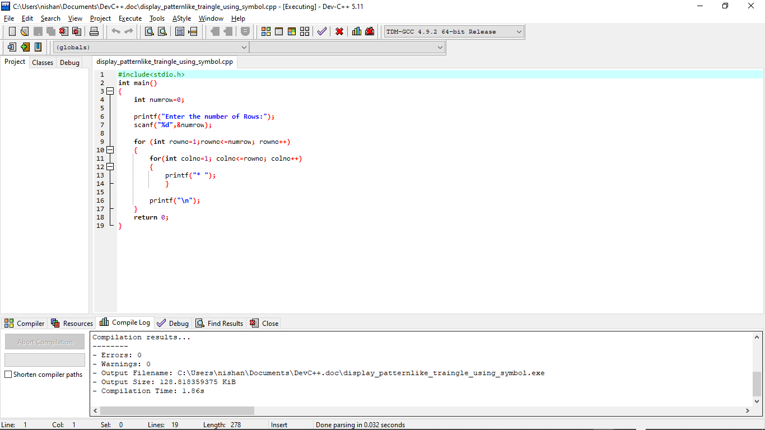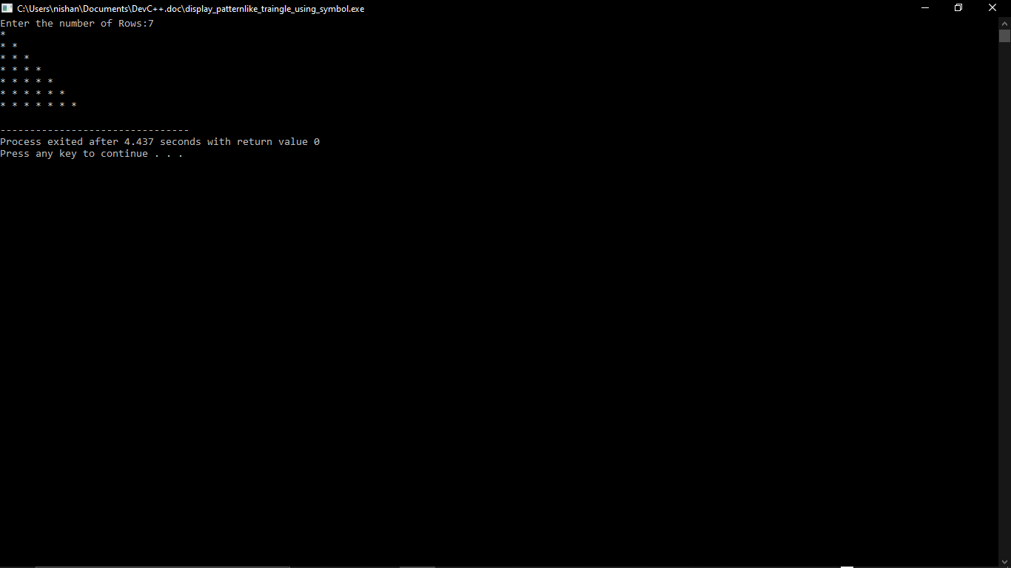**Solution in Dev-C++:**

**Output**:

1. **Write a program in C to display the pattern like right angle triangle with a number.**

**The pattern like:**

**1**

**1 2**

**1 2 3**

**1 2 3 4**

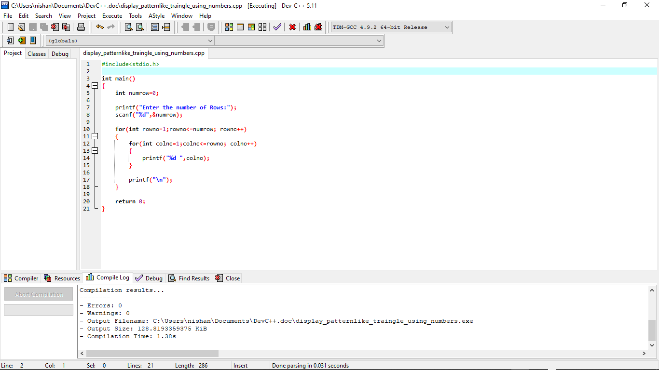**Solution in Dev-C++:**

**Output:**

